Allied path to victory in Europe

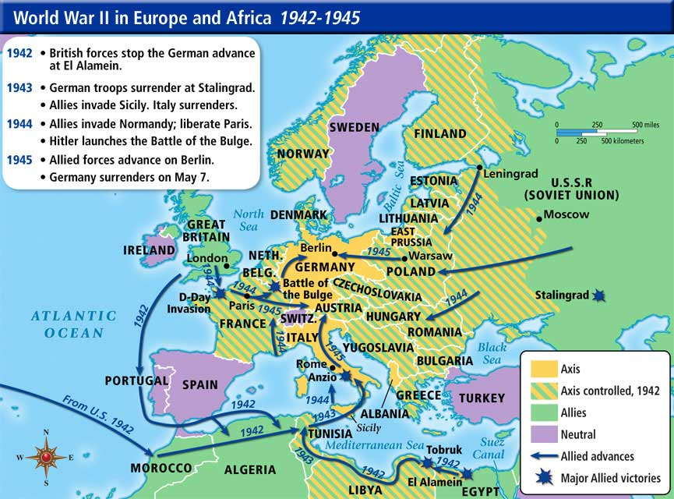

1. Where did the U.S. Army 1st land to fight the Germans? _______________
2. What were two major victories in Africa in 1942? ____________ & _____________
3. When did the D-Day invasion occur? ________________
4. What two major Allied victories occurred 1943? ______________&______________
5. What Allied country was the 1st to capture Berlin? ______________
6. Find two pictures of Operation Overlord and attach them to the bottom of this page.